Project Design Phase-II
Solution Requirements (Functional & Non-functional)
Technical Specifications Matrix for my-mern-project
Date | 12 July 2026
Team ID
Project Name | Darshan ease
Maximum Marks | 4 Marks

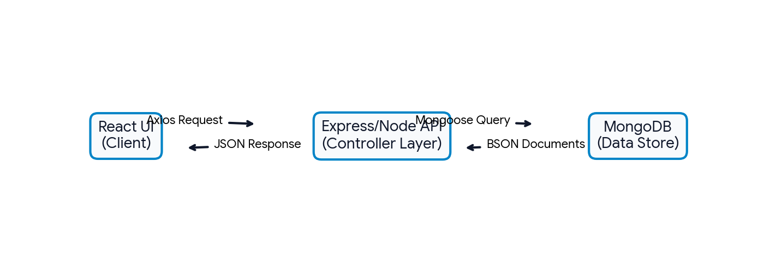
Figure 2.1: Modern Solution Requirements Architecture Flow for MERN Data Interactions.
Functional Requirements
Following are the functional requirements of the proposed solution mapping out user workflow interactions:
FR No. | Functional Requirement (Epic) | Sub Requirement (Story / Sub-Task)
FR-1 | User Registration | • Registration through standard Web Form  • Registration through Gmail OAuth2  • Registration through LinkedIn Provider
FR-2 | User Confirmation | • Confirmation via Verification Email link  • Confirmation via 6-digit dynamic OTP code
FR-3 | State Management & Dashboard | • Live update context status feed  • Dynamic data manipulation grids for MERN operations
FR-4 | Secure Session Access Control | • Session persistence via HTTP-Only token mechanics  • Automatic session clear validation rules upon logout

Non-functional Requirements
Following are the non-functional qualitative benchmarks required by the proposed application architecture:
NFR No. | Non-Functional Requirement | Target Metric & Implementation Description
NFR-1 | Usability | Responsive UI/UX rendering fluidly on mobile breakpoints and desktop layout Viewports.
NFR-2 | Security | End-to-end data transit payload masking, bcrypt hashing, and secure token access controls.
NFR-3 | Reliability | Zero data loss transaction workflows ensuring high fault tolerance across API micro-instances.
NFR-4 | Performance | Extremely fast payload round-trips with server side API endpoint execution within <200ms benchmarks.
NFR-5 | Availability | High cloud deployment resilience targets maintaining a continuous 99.9% uptime track record.
NFR-6 | Scalability | Horizontal auto-scaling capability handling concurrent database requests cleanly via cloud nodes.

